**17. ReactJS-HOL**

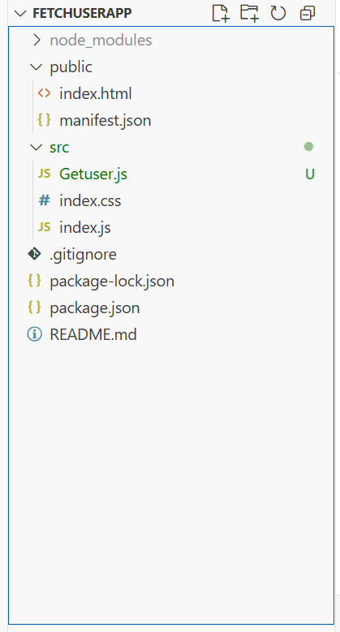

**Getuser.js**

import React, { Component } from 'react';

class Getuser extends Component {

constructor(props) {

super(props);

this.state = {

person: null,

loading: true

};

}

async componentDidMount() {

const url = "https://api.randomuser.me/";

const response = await fetch(url);

const data = await response.json();

this.setState({ person: data.results[0], loading: false });

console.log(data.results[0]);

}

render() {

const { person, loading } = this.state;

if (loading) {

return <h2>Loading...</h2>;

}

return (

<div style={{ textAlign: 'center', marginTop: '50px' }}>

<h2>

{person.name.title} {person.name.first} {person.name.last}

</h2>

<img src={person.picture.large} alt="user" />

</div>

);

}

}

export default Getuser;

**App.js**  
import React from 'react';

import Getuser from './Getuser';

function App() {

return (

<div className="App">

<Getuser />

</div>

);

}

export default App;

